Bugs Resolved

Below is a list of bugs resolved and minor enhancement in the Earhart patch release v18.0.75 / v2508_2_1

File Uploader

Frog Reference | CSD Reference |  | ALM# | Summary
SA-812 |  | N/A | N/A | When using a mobile or tablet device, the “File Uploader” pop-up window will display slightly differently compared to a desktop. When triggered, it will show the following two options:  - Browse – Opens your device’s available file sources, such as the photo library or documents manager.  - Use Camera – Launches your device’s camera, allowing you to take a photo which is then automatically uploaded to the File Uploader window.  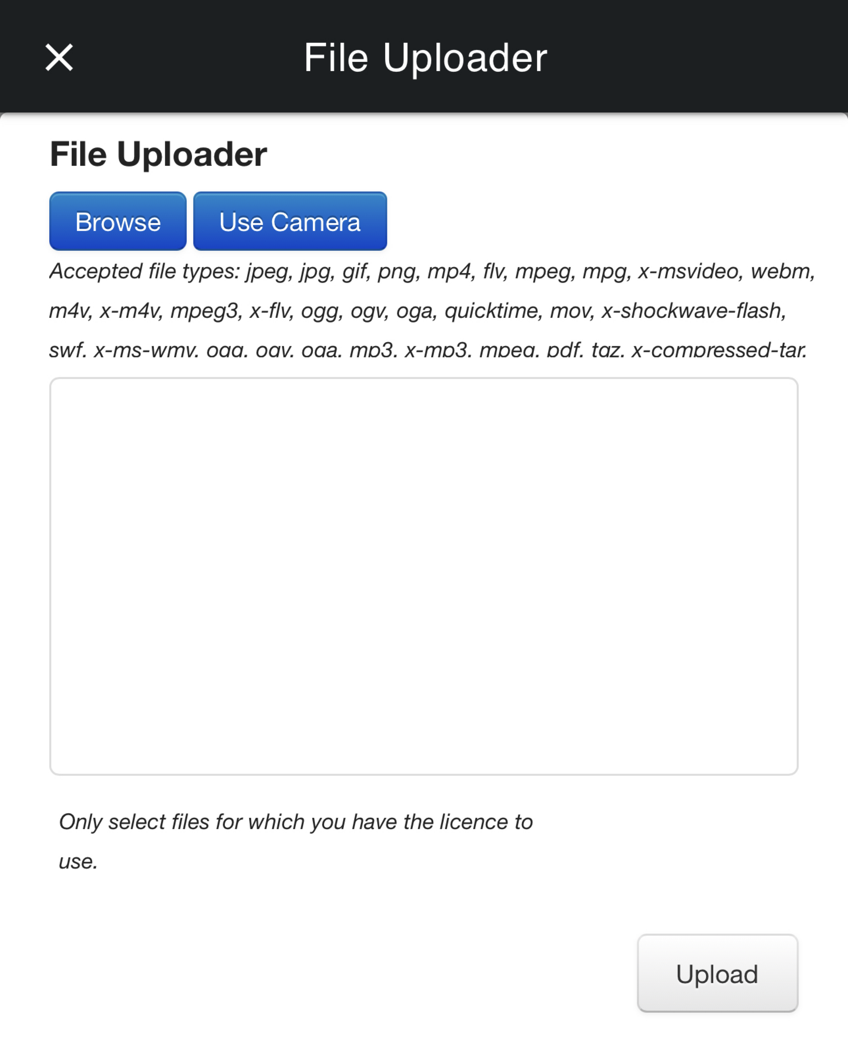  To complete the process of adding your files to a site, announcement, chat, or journal post, select the “Upload” button.

Frog GO Mobile Application

Frog Reference | CSD Reference |  | ALM# | Summary
SA-1125 |  | N/A | N/A | Safeguards have been added to the Frog GO mobile application to handle scenarios where internet connectivity is slow. These improvements should prevent the “app.container” error from occurring intermittently when users select push notifications.
SA-1150 |  | N/A | N/A | The Frog GO mobile application has been enhanced to work seamlessly with the Firefox browser.
SA-1178 |  | N/A | N/A | When the Create Event widget is placed on a dashboard or site and accessed via the Frog GO mobile application, tapping into the ‘Title’ or ‘Location’ fields will now correctly trigger the mobile keyboard, allowing users to enter content as expected.
SA-1204 |  | N/A | N/A | The Frog GO mobile application has been updated to remove the “Access app content over WiFi only” toggle from the landing page. Content delivery is now managed by the device’s own data settings.
SA-1221 |  | N/A | N/A | When a staff or admin user receives a push notification for a reply to an announcement they have sent, selecting the notification will take them directly to the announcement, landing on the “Replies” area.

